|  |
| --- |
| RETAIL MANAGEMENT APPLICATION USING SALESFORCE |
| PROJECT BASED EXPERIENTIAL LEARNING PROGRAM |
| VISHNU VARTHANI.K |

# INTRODUCTION

#### OVERVIEW

Salesforce is game-changing technology, with a host of productivity-boosting features, that will help you sell smarter and faster. Salesforce is the World’s number one customer relationship management CRM platform.Its help in marketing sales, service, commerce and IT teams works as one from anywhere in the world. This can help field sales teams ensure that order fulfilled quickly and accurately and that inventor levels are maintained at optimal levels.

## PURPOSE

Retailing encompasses the business activities involved in selling goods and services to consumers for their personal, family, or household etc. A CRM product owner has requested to create two applications, one is a sales app for sales reps to use this application and store customers data, and the second application is a service app for service reps/agents to provide support to customers in dealing cases. To generate business on top of the customers.

# PROBLEM DEFINITION &DESIGN THINKING

## EMPATHY MAP

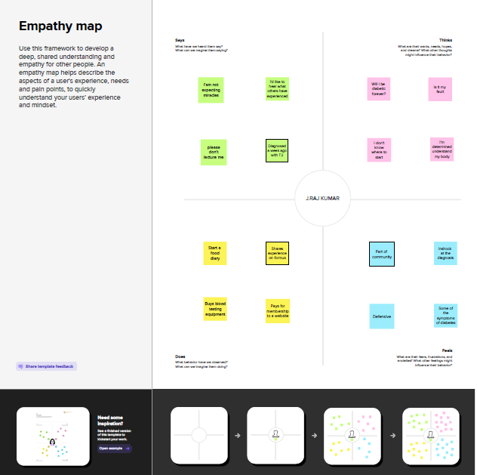

Vishnu Varthani

## BRAINSTORM AND IDEA PRIORITIZATION MAP

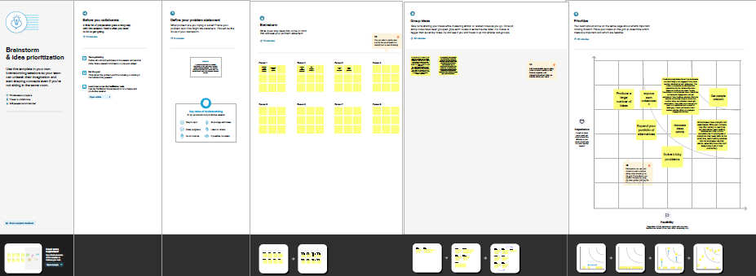

# RESULTS

## DATA MODEL

|  |  |
| --- | --- |
| **Object name** | **Fields in the Object** |
| Standard object | |  |  | | --- | --- | | Field label | Data type | | Account | Text | | Contact | Number | |
| Custom object | |  |  | | --- | --- | | Field label | Data type | | Dispatch/Tracking | Text | | Warehouse | Text | |

# ACTIVITY & SCREENSHOT

## MILESTONE: 1 Creating Developer Account in salesforce

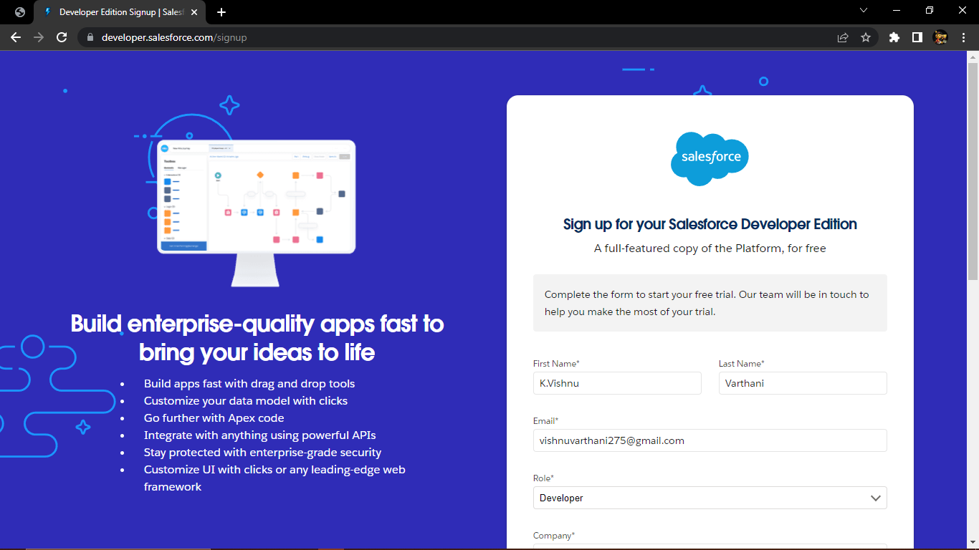

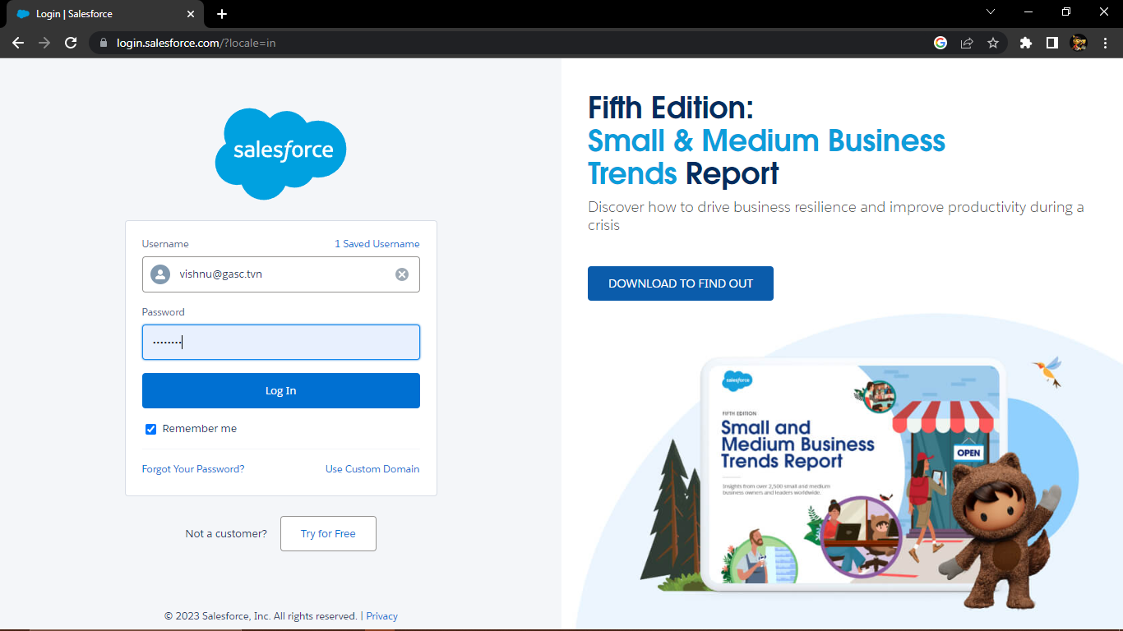

## C:\Users\Anathur PC\Pictures\Screenshots\New folder\Screenshot (37).png

# Milestone: 2 Objects

Objects are database tables that permit you to store data that is specific to an organization .Salesforce objects are of two types:

1. Standard objects: Account, Contact, Leads, Opportunities, Camping.
2. Custom objects: Dispatch/Tracking, Sales order, Warehouse, Products.

## Activity-1

## Creation of object Dispatch/Tracking

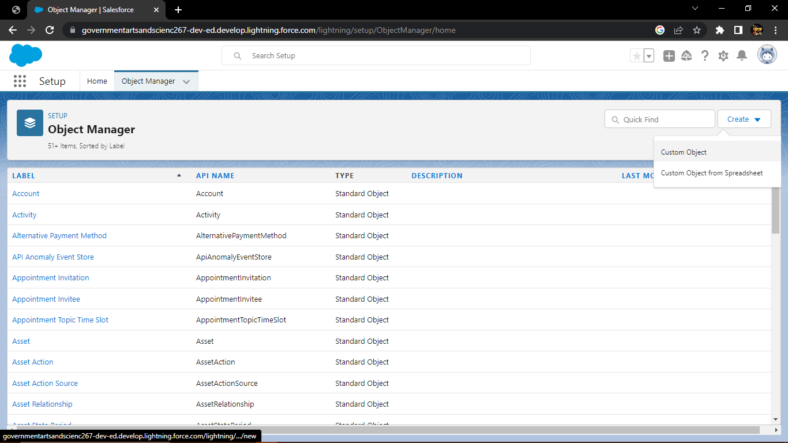

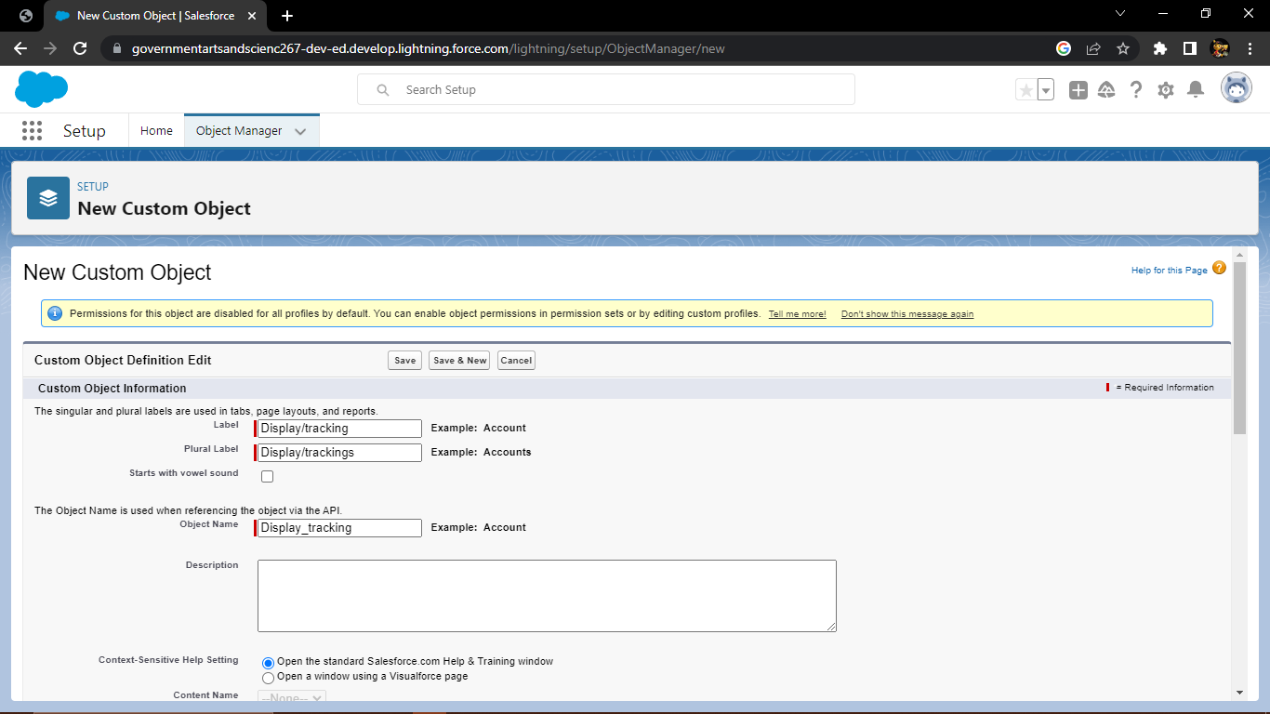

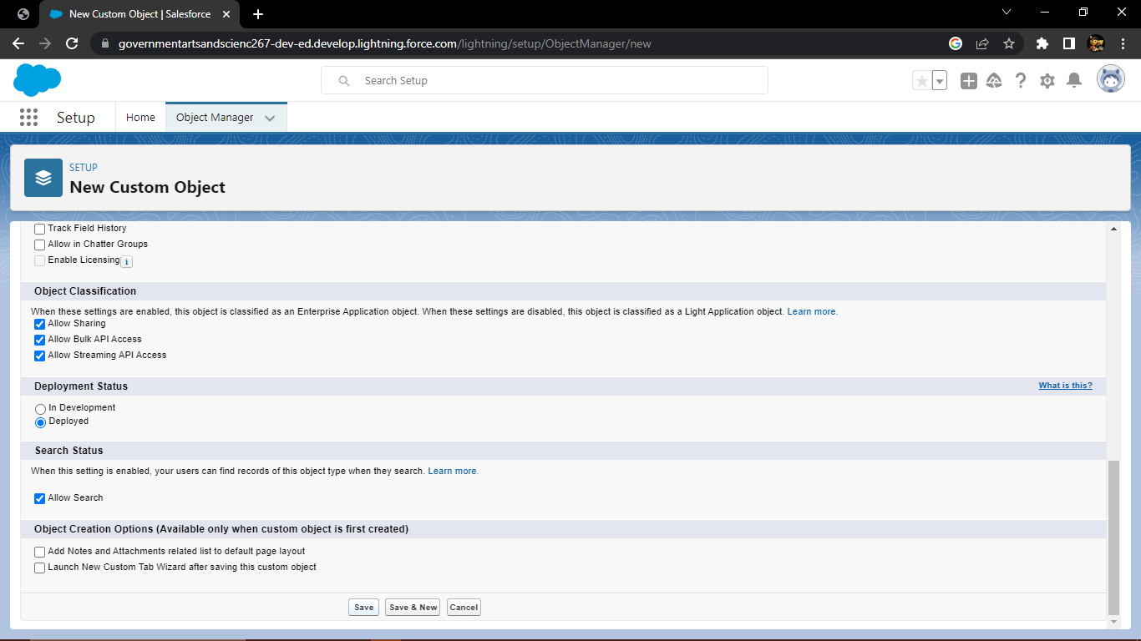

## Create Tab for Dispatch/Tracking

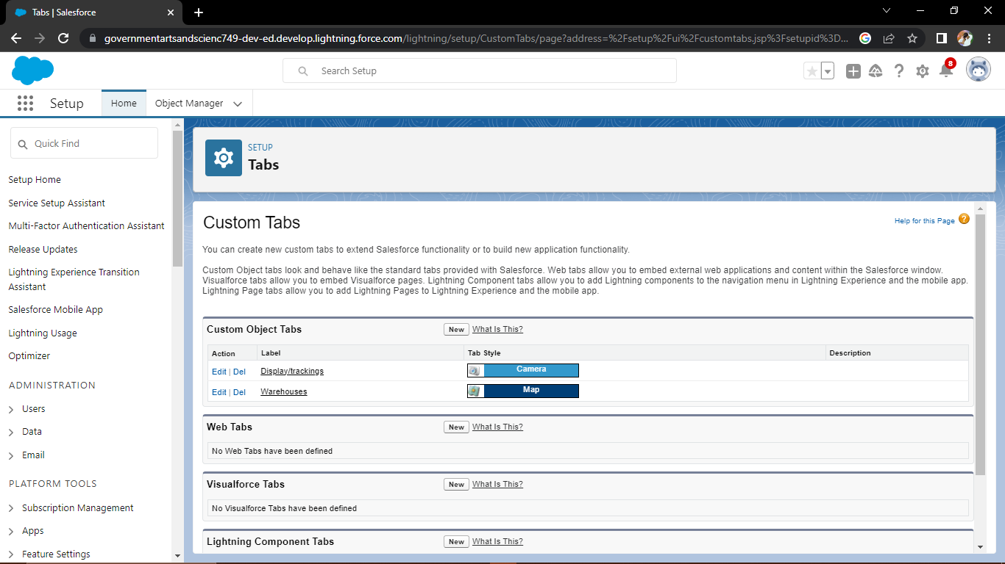

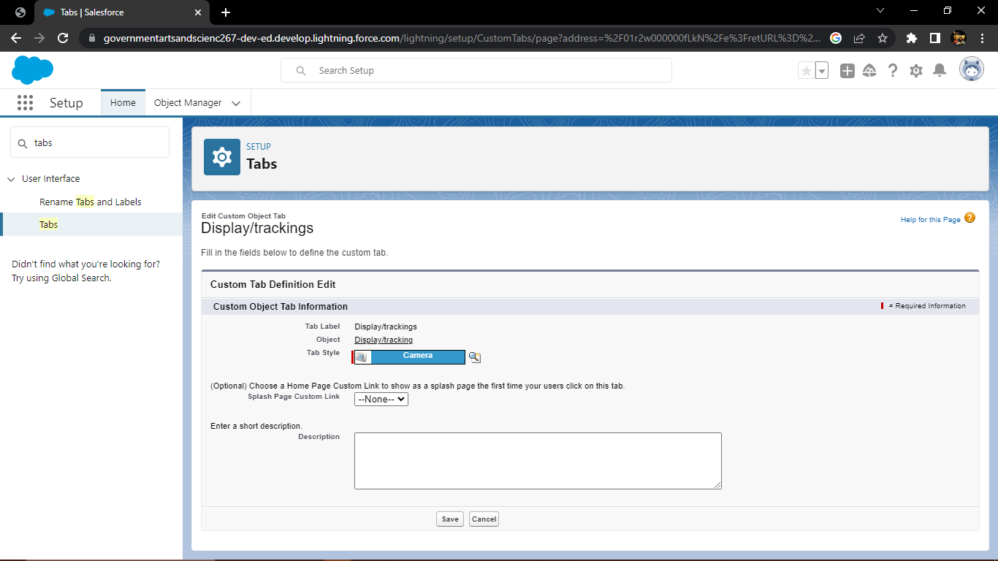

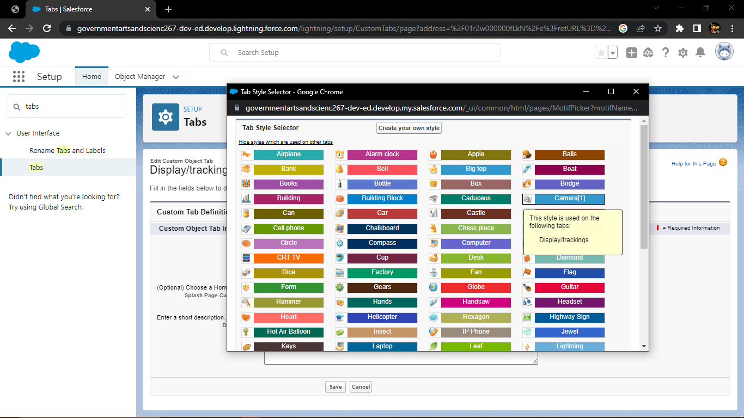

## C:\Users\Anathur PC\Pictures\Screenshots\New folder\Screenshot (53).png

## Creation of object of Warehouse

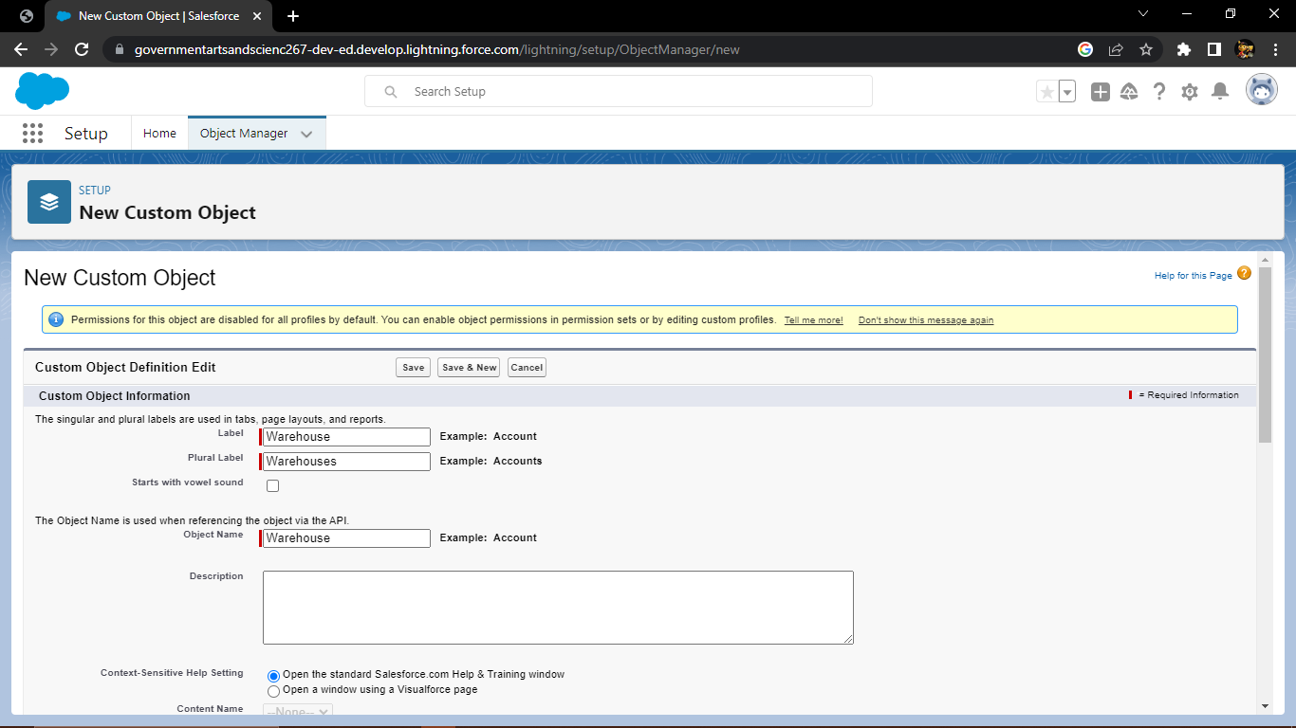

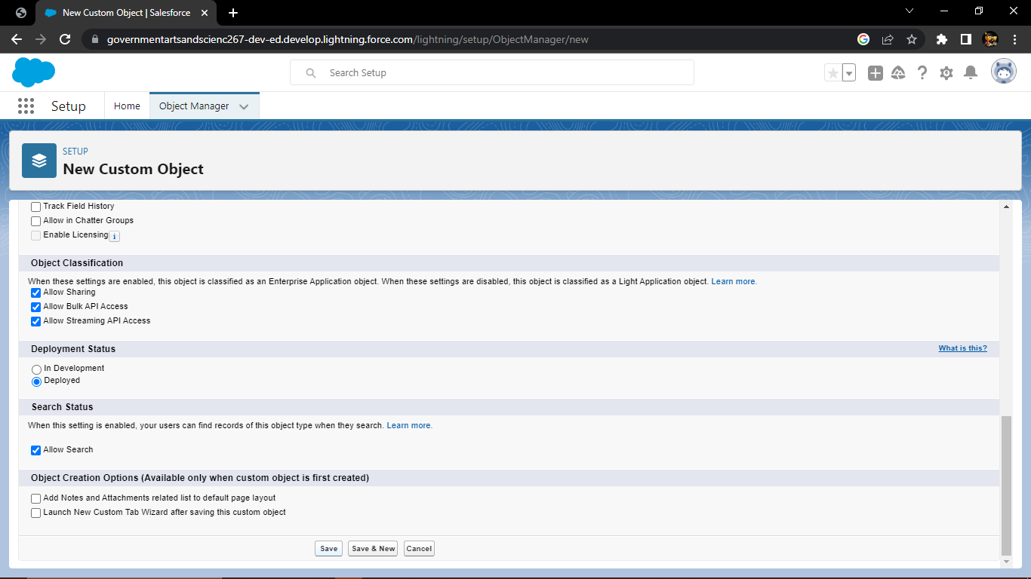

## Creation of tab for Warehouse

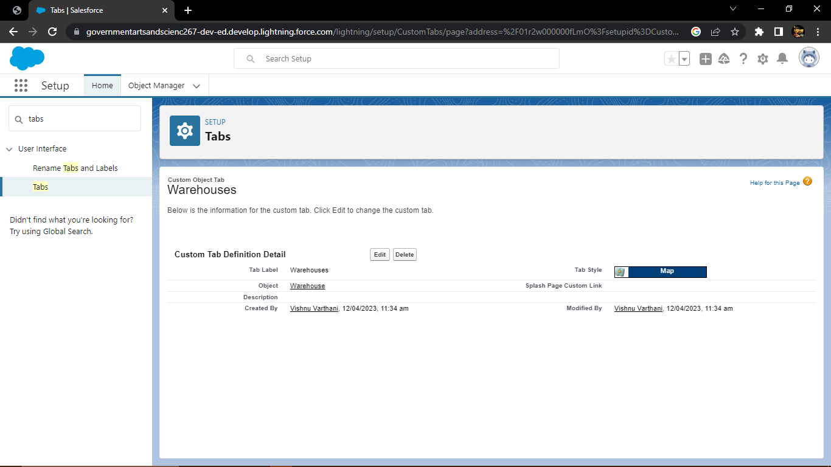

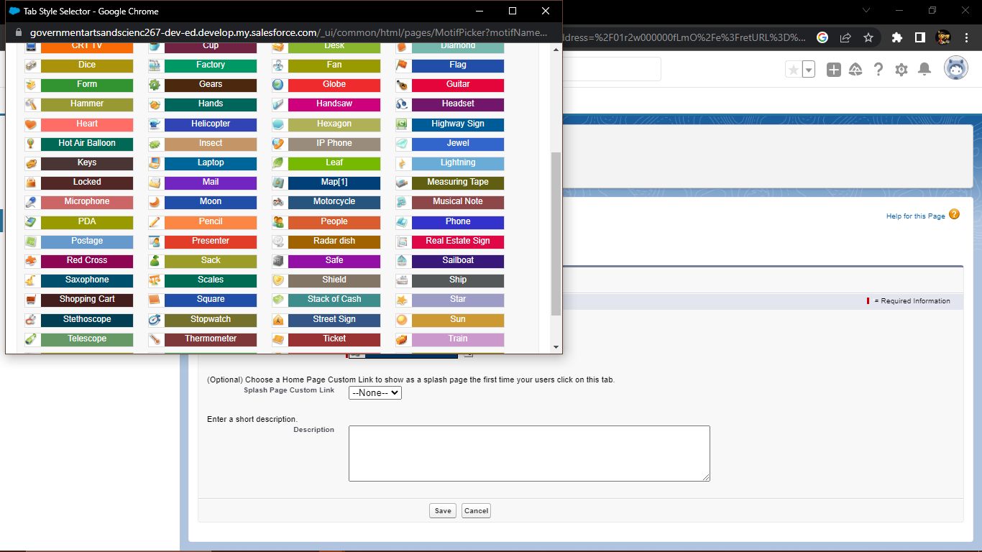

# Activity-2

## Creation of fields on Dispatch/tracking

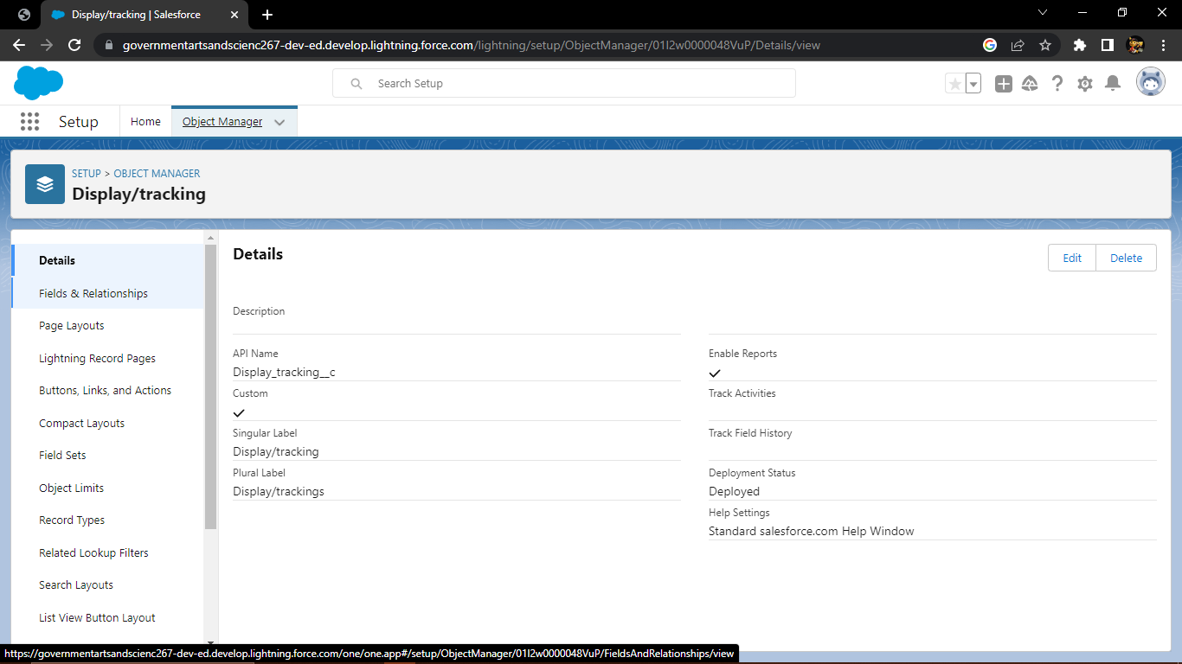

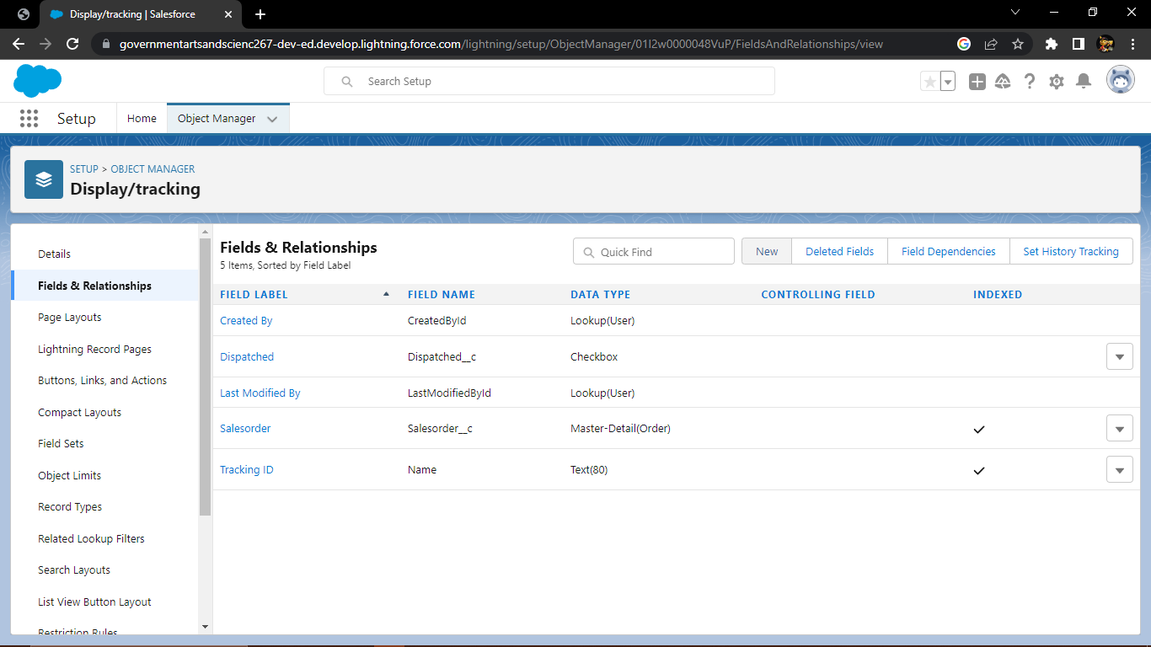

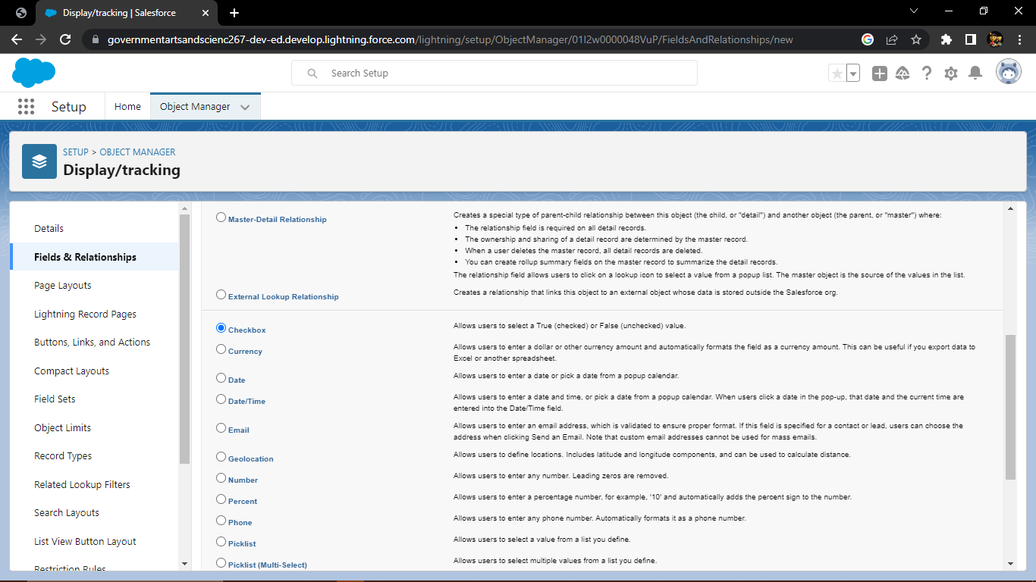

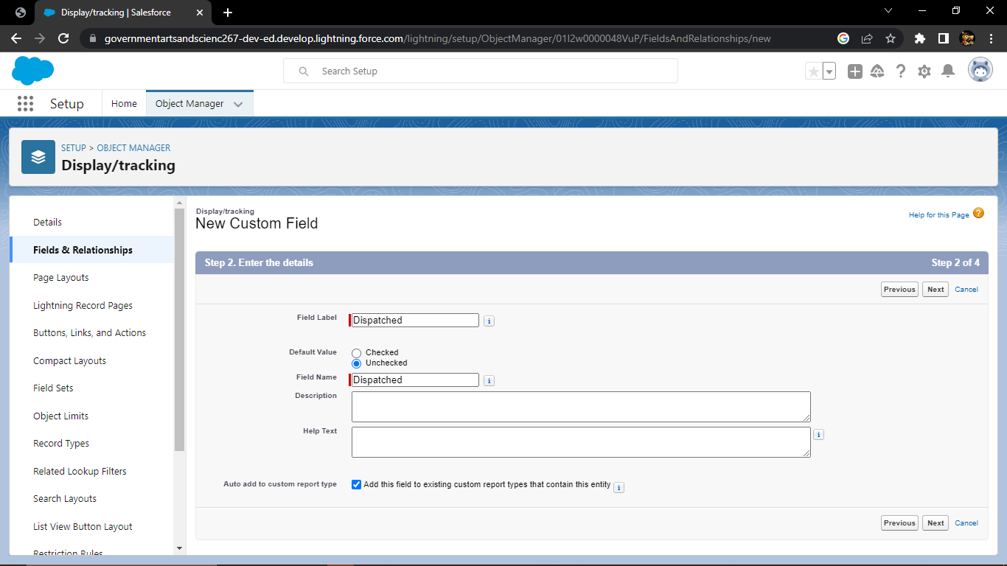

# Milestone-3 Relationship b/w objects:

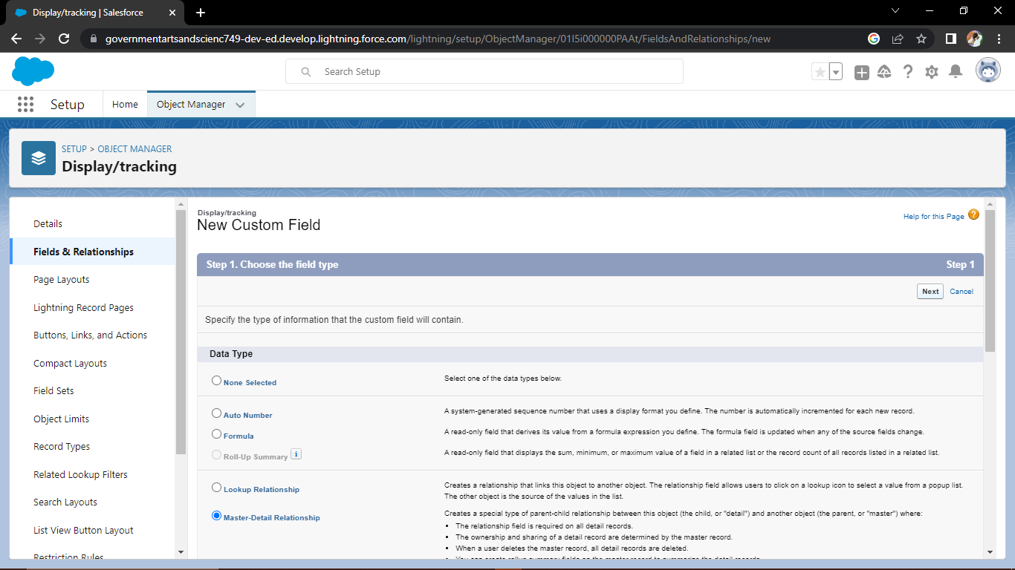

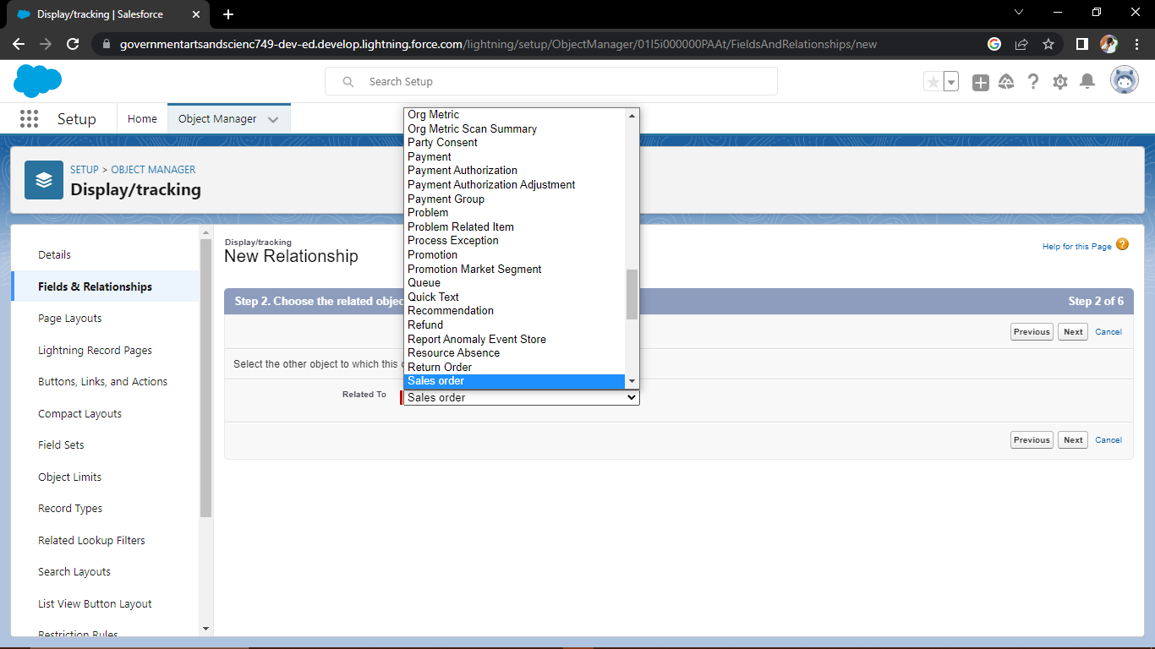

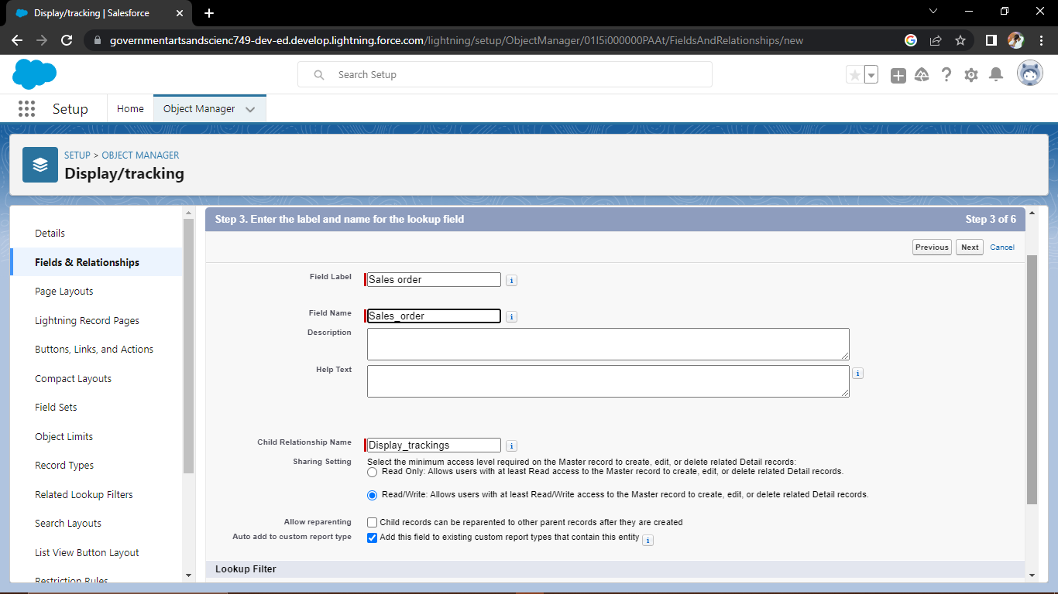

# C:\Users\Anathur PC\Pictures\Screenshots\Screenshot (81).png

# Milestone-4 Application:

## Activity-1

## Creation of Application

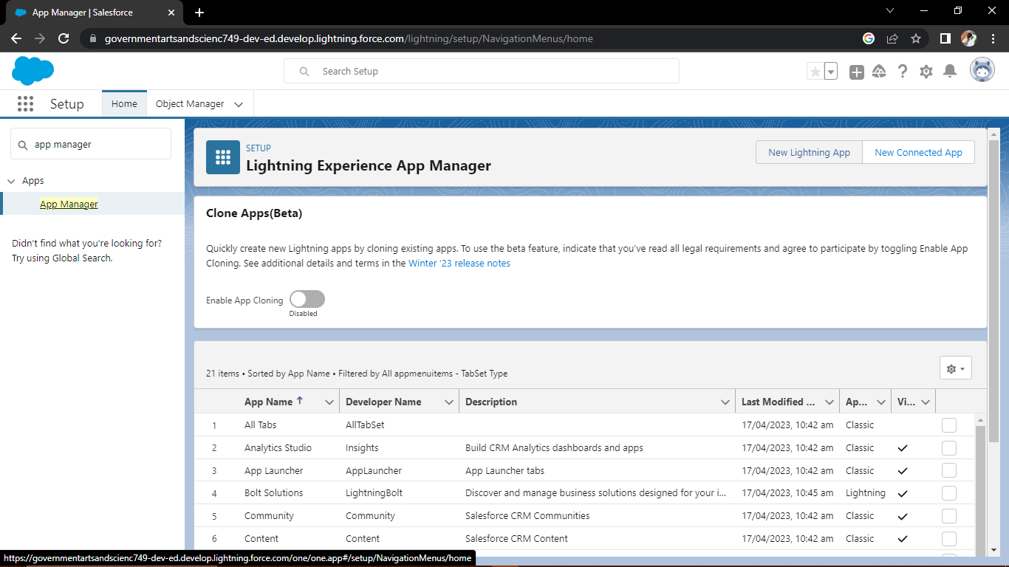

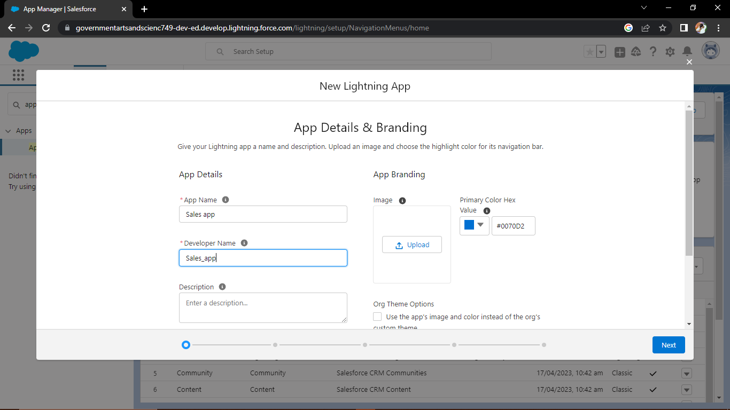

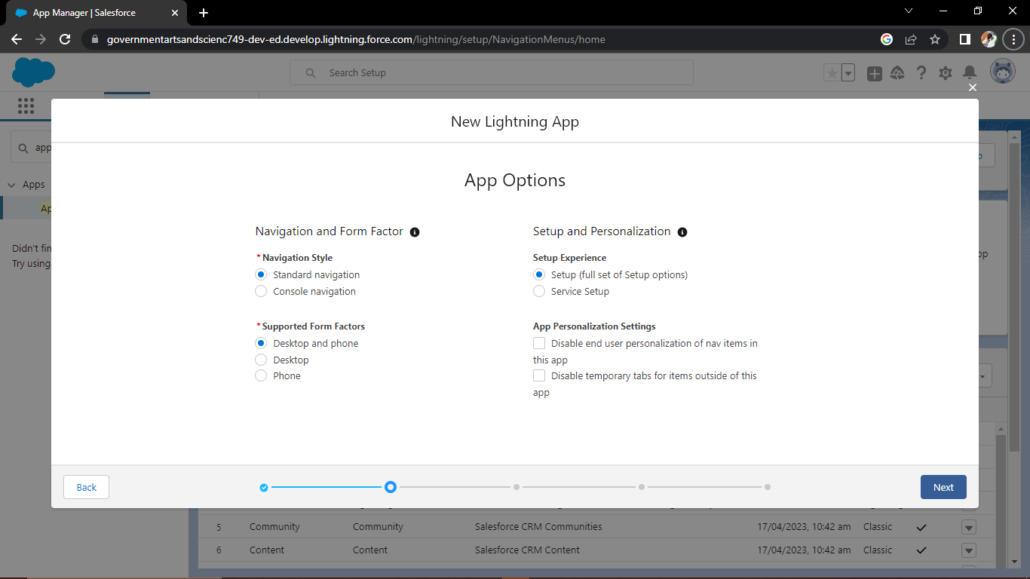

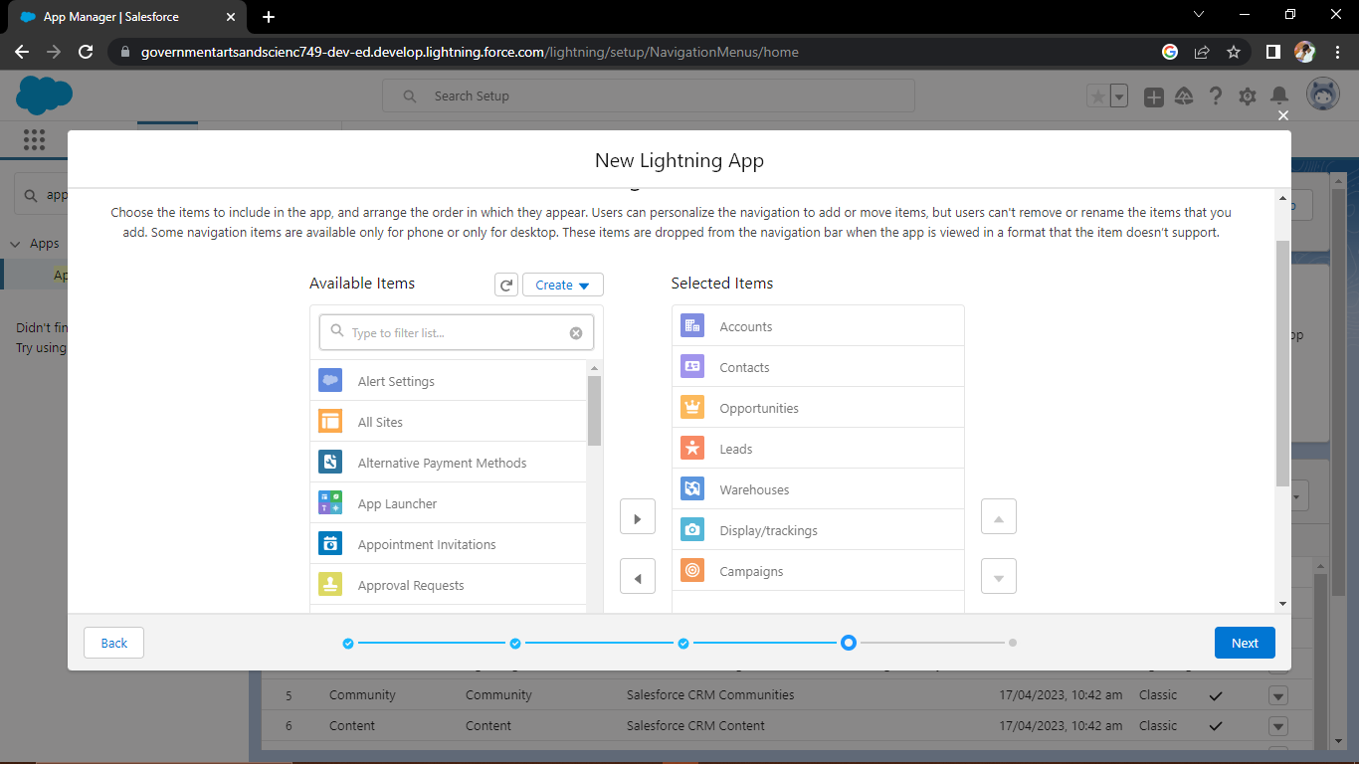

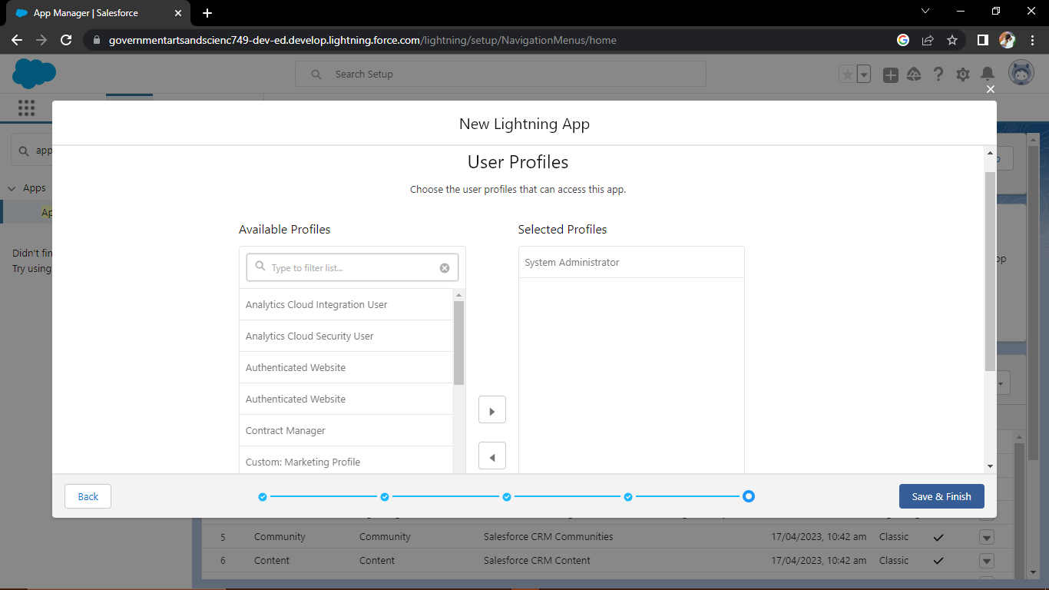

# Milestone-5 Layouts:

## Activity-1:

## Creation of custom Tabs

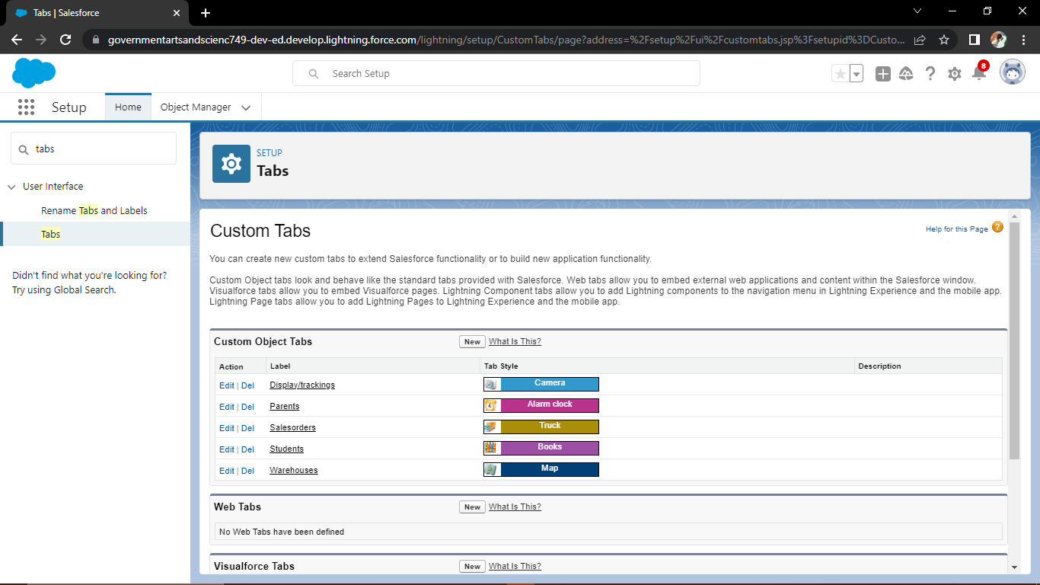

# Milestone-6 User:

## Activity-1:

## Creation of user

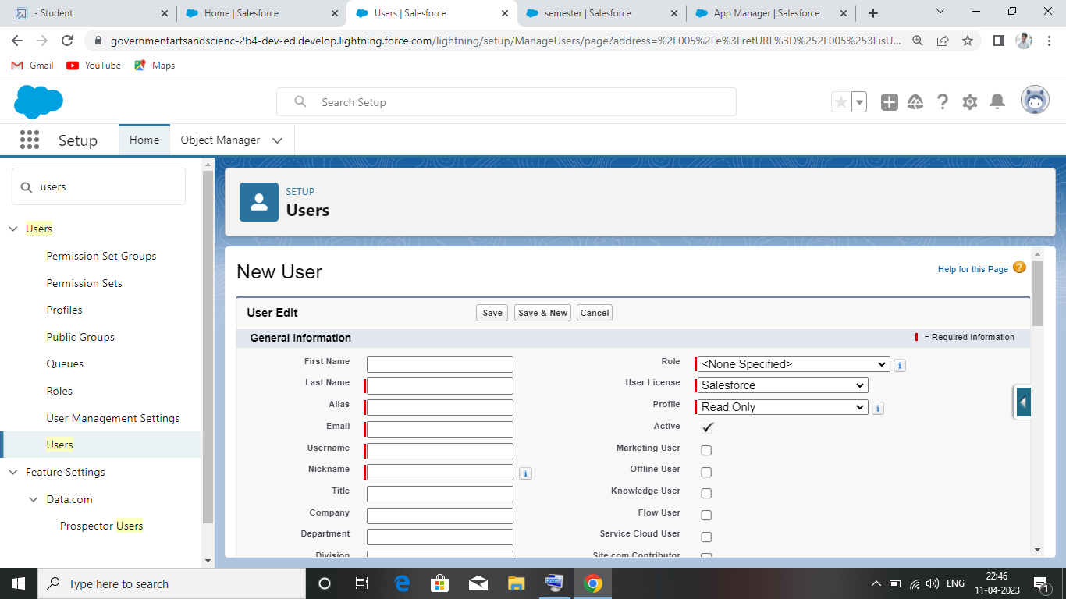

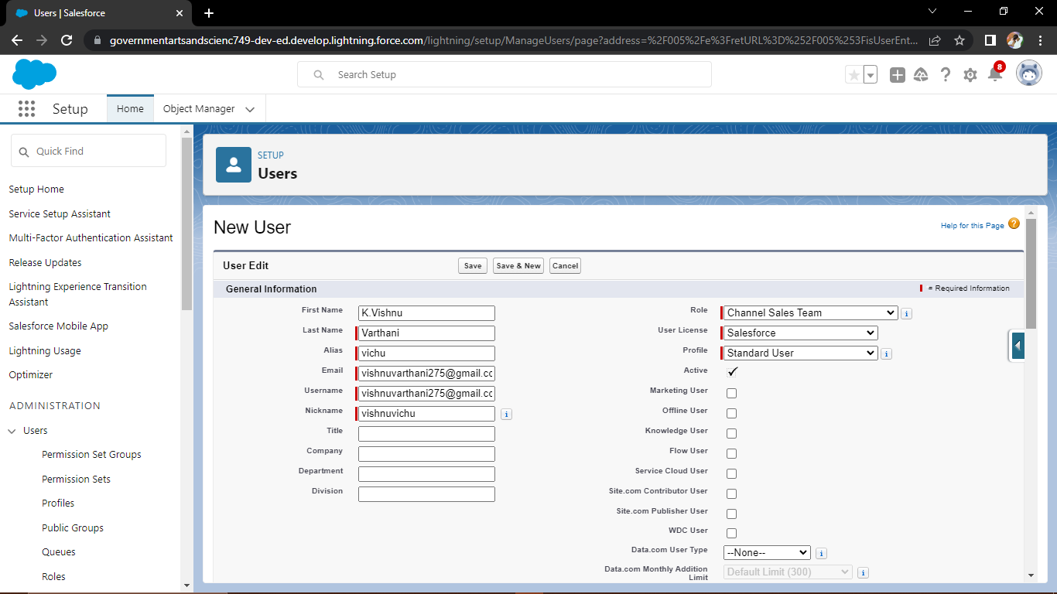

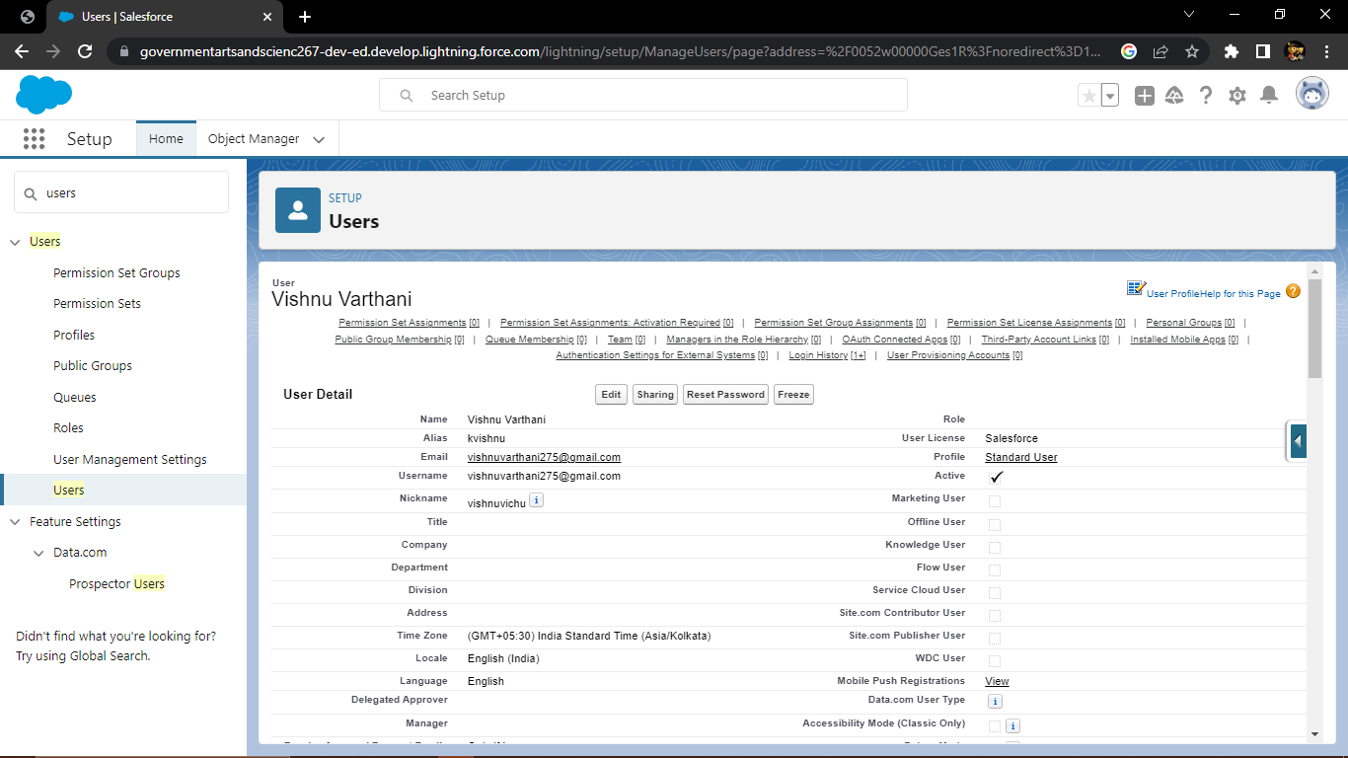

# Milestone-7 Validation Rules:

## Activity-1:

## Creation of validation rule

## C:\Users\Anathur PC\Pictures\Screenshots\Screenshot (93).png

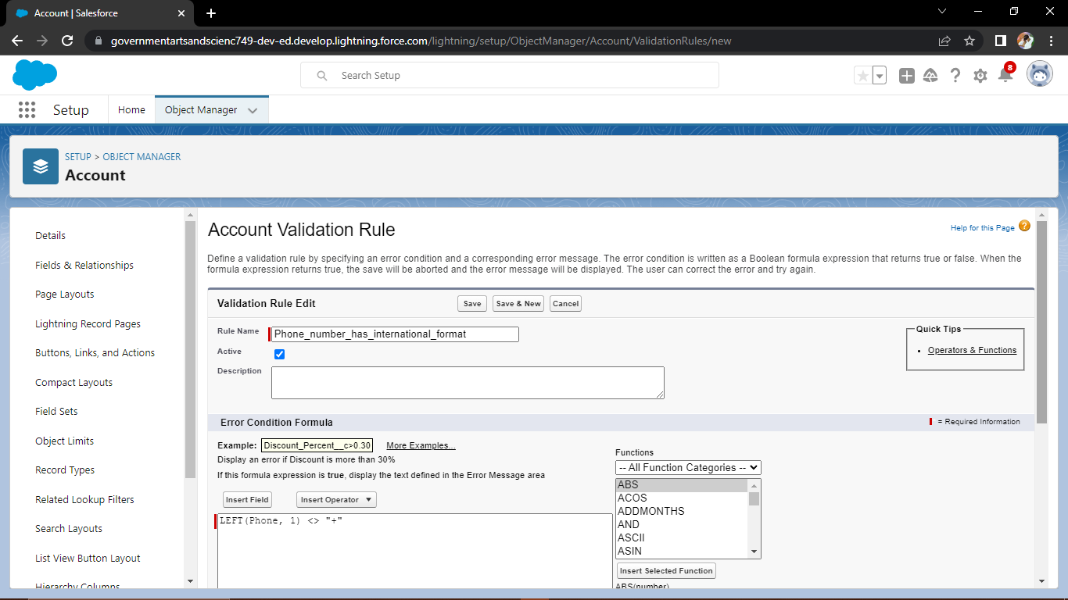

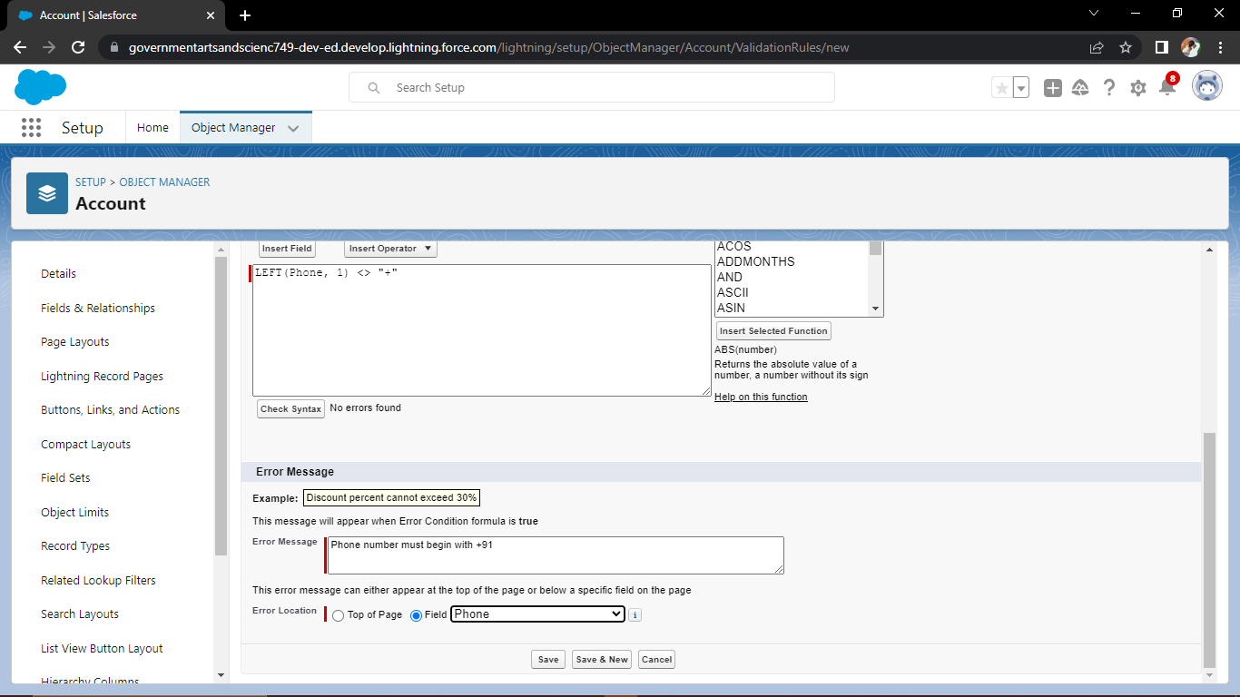

## Activity-2:

## Cross Object Formula

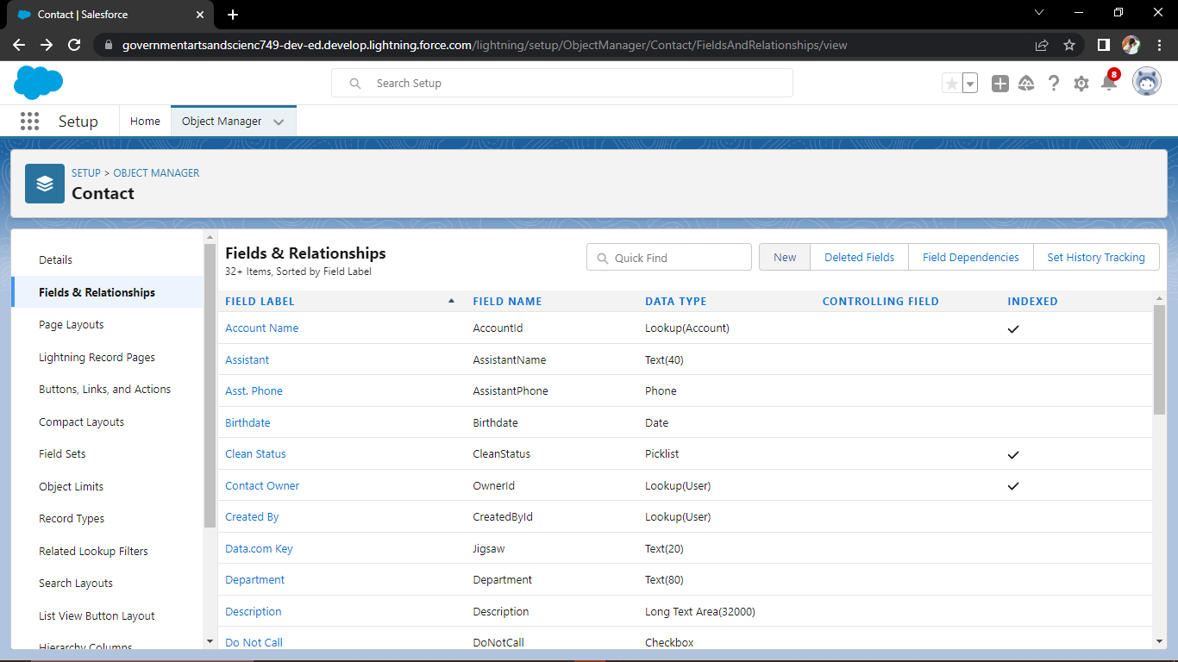

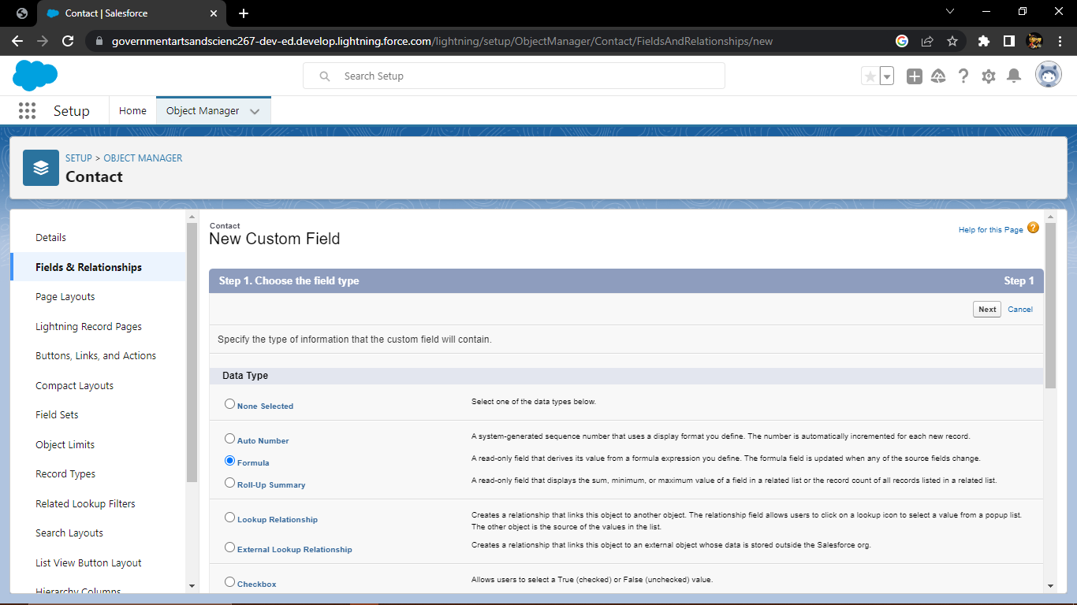

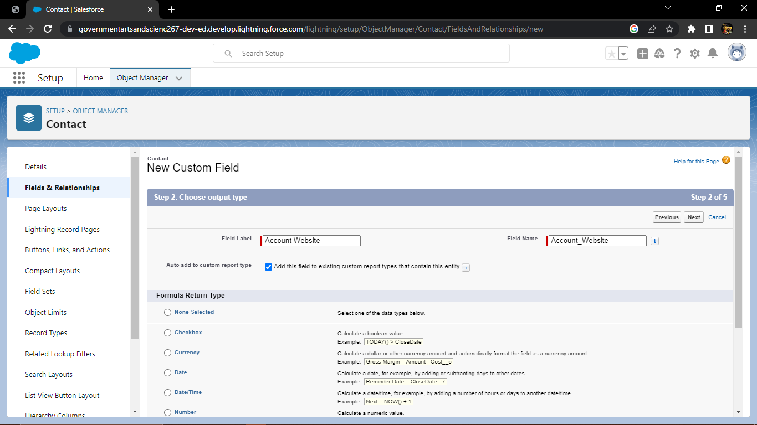

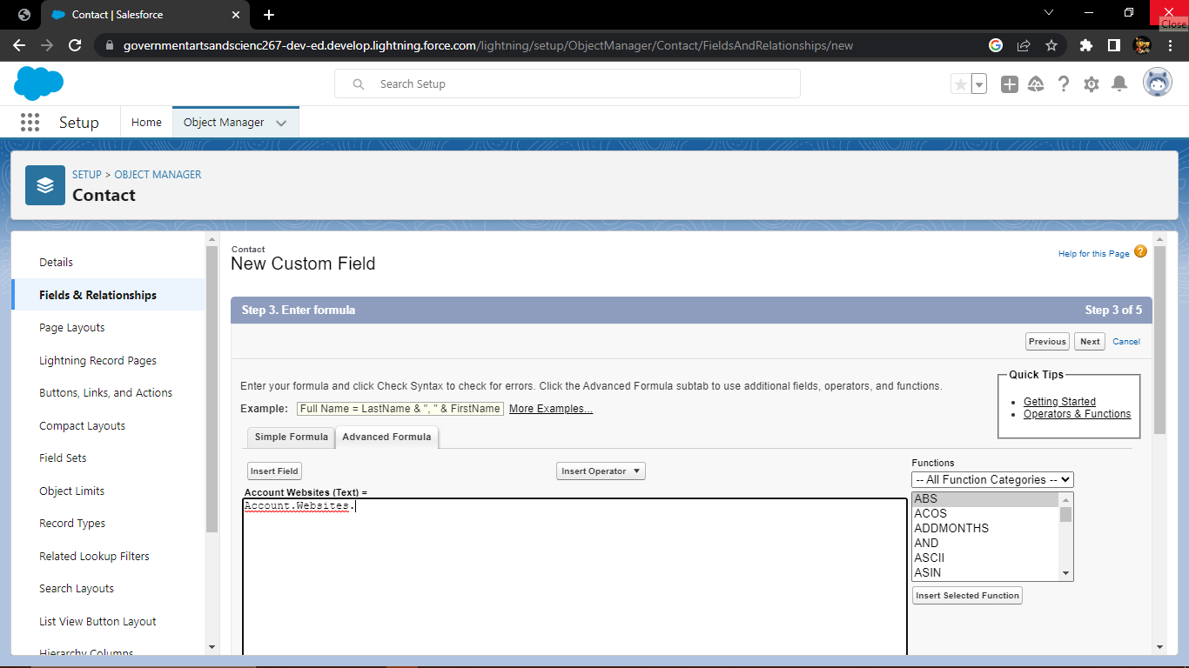

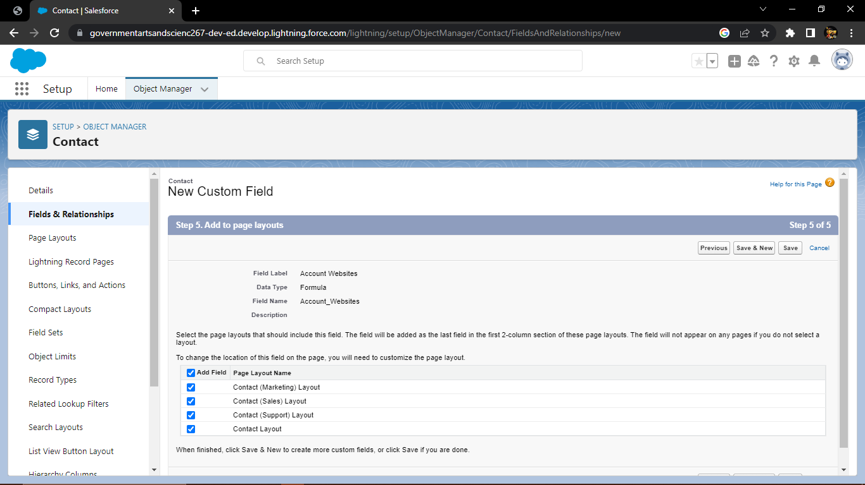

# Milestone-7 Reports:

## Activity:

## Creation of report

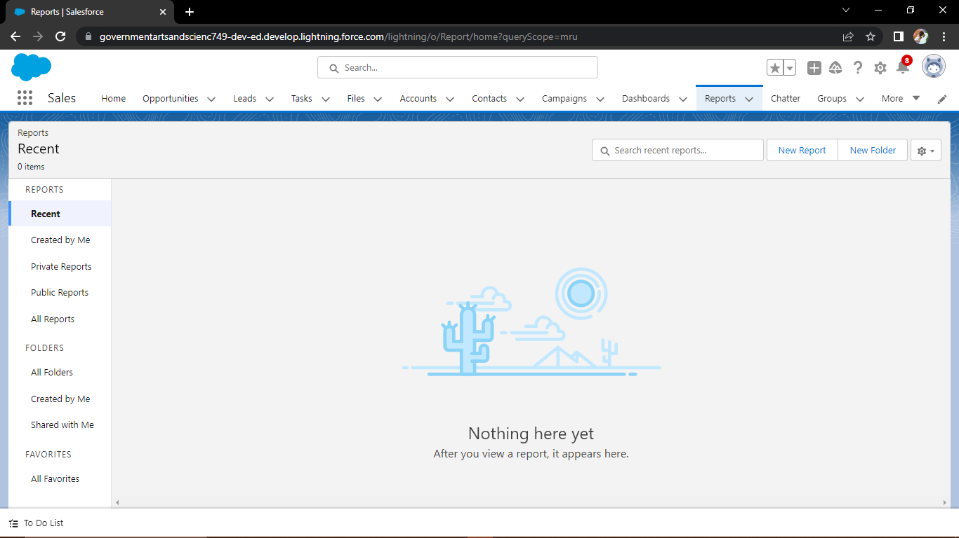

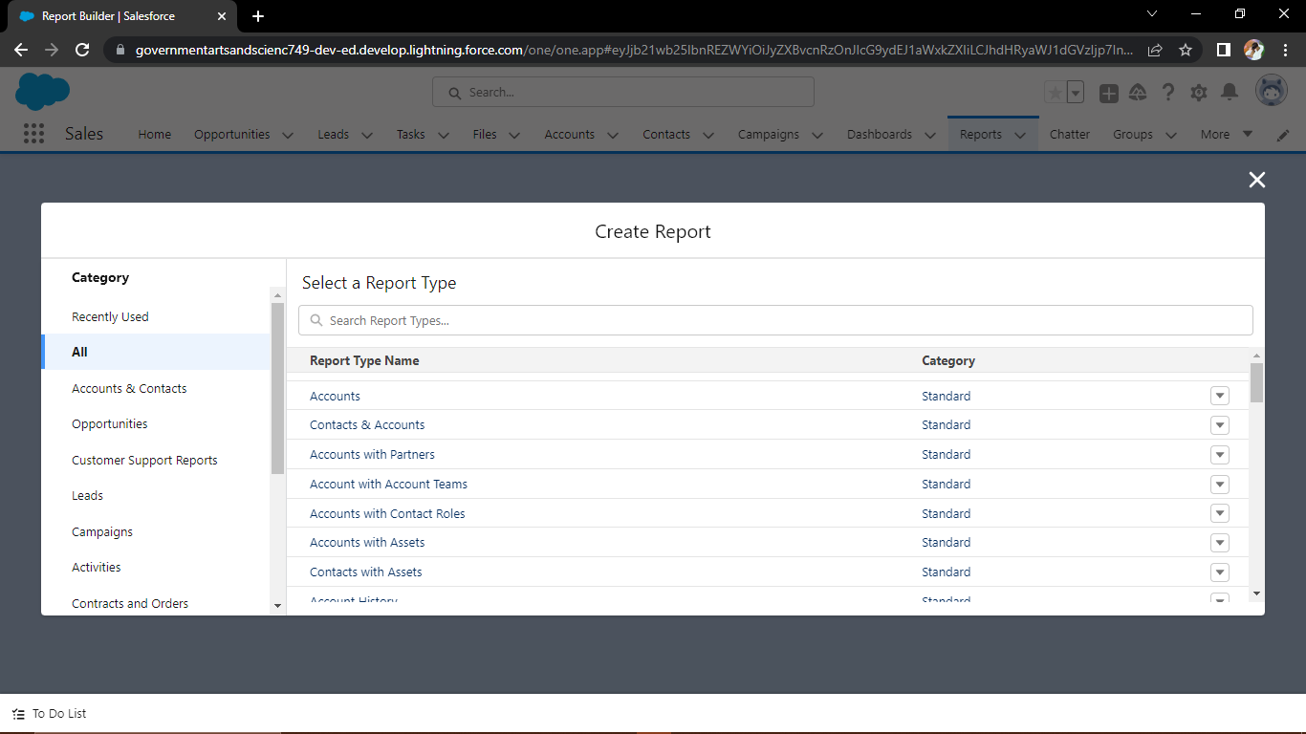

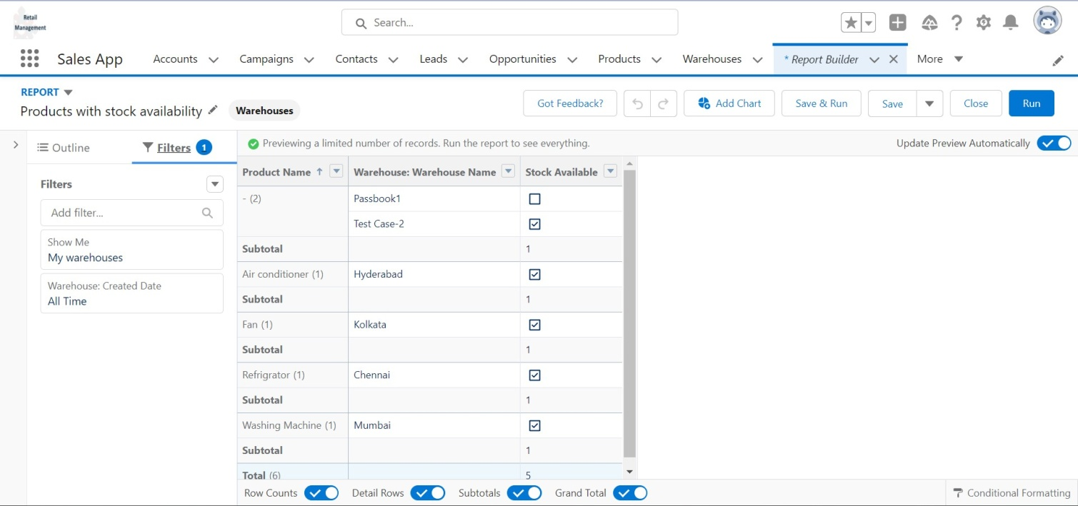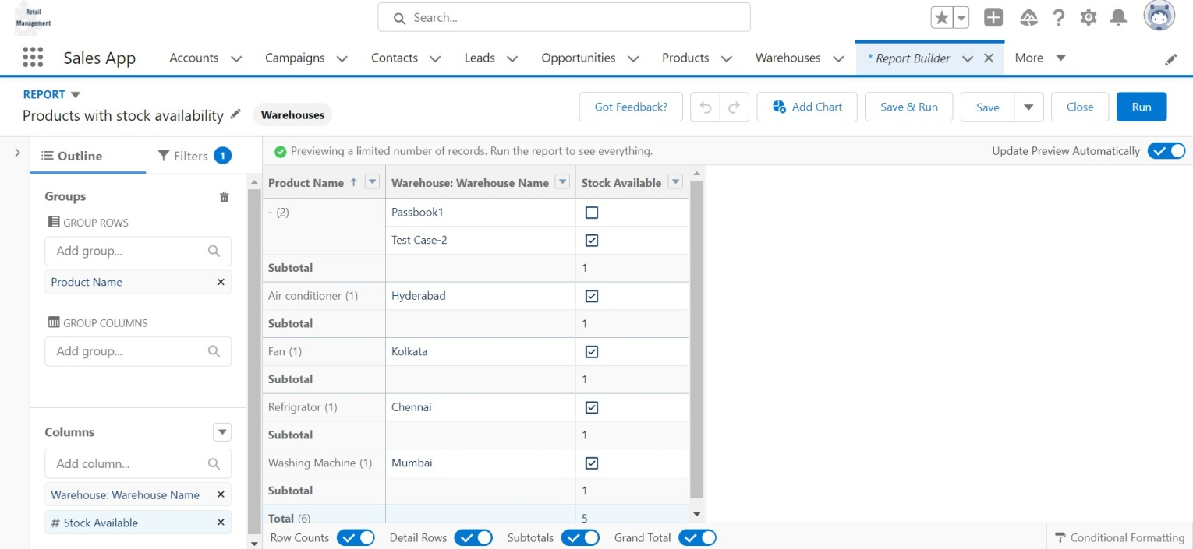

# Milestone-8 Dashboards:

## Activity

## Creation of Dashboard

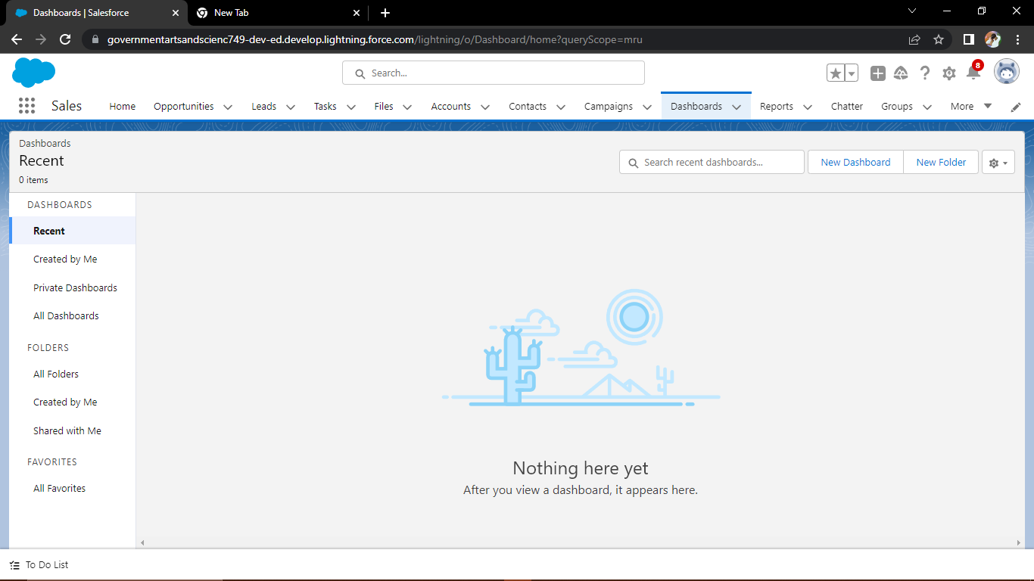

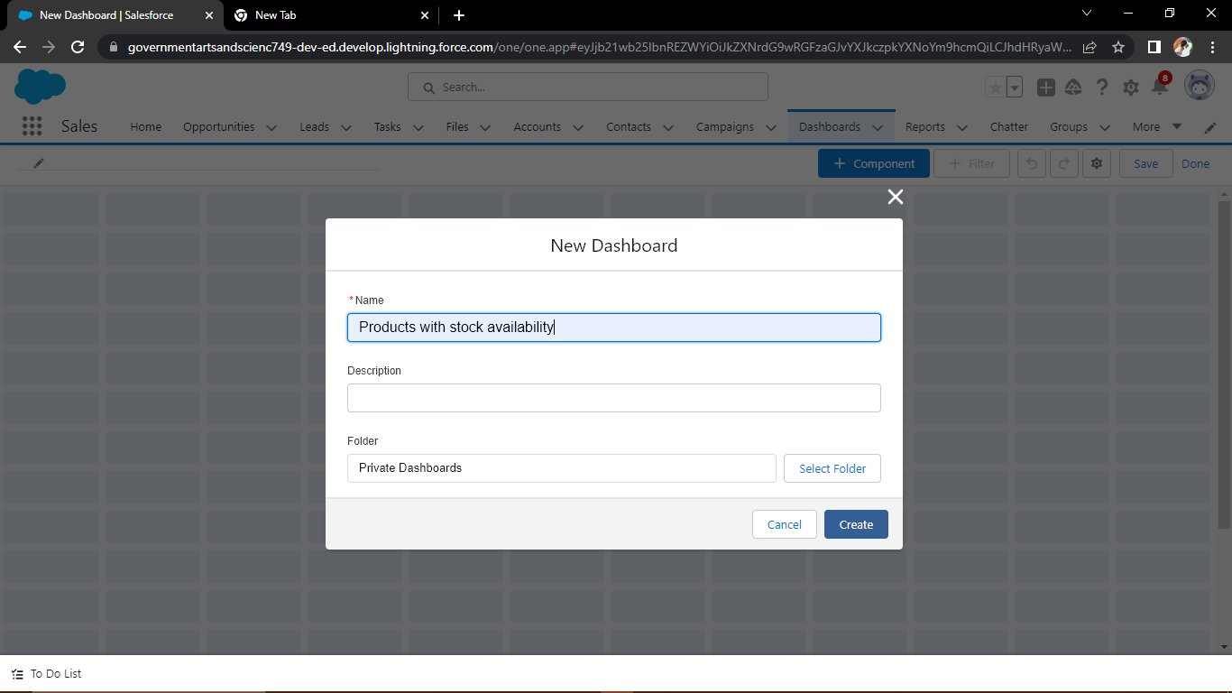

# 4. TRAILHEAD PROFILE PUBLIC URL

**Team Lead -** <https://trailblazer.me/id/vishnuk02>

**Team Member 1 -** <https://trailblazer.me/id/vnithya311>

**Team Member 2 -** <https://trailblazer.me/id/kmaha28>

**Team Member 3** - <https://trailblazer.me/id/smageshwari>

# ADVANTAGES & DISADVANTAGE

## ADVANTAGES

Retail management can help a company operate effectively and increase its overall number of sales.

Retail managers handle different tasks for a business to implement procedures and monitor its productivity. By learning more information about retail management, you can better understand how it works and determine if it can provide the right career path for you.

In this article, we discuss what retail management is, list the different retail management processes, explain why it's beneficial to have effective processes, describe types of retail manager positions and provide steps for how to earn one.

## DISADVANTAGE

## Large retailers move enormous amounts of product each day. If your product is an unknown, you're going to have a difficult time selling it to the biggest retailers.

## Company.com explains that getting your product stocked at retail giants requires you to have a track record of success.

## Large retailers only want items that consumers are going to buy, and they don't need to take a risk on the unknown.

# APPLICATIONS

A retail management system (RMS) is a platform that combines several modules to aid in the day-to-day operation of a retail store or chain, such as managing and buying inventory, checking out customers, scheduling employee shifts, keeping track of finances

# CONCLUSION

In this course we have explored the meaning of the terms retailing, marketing and marketing communications. We have also considered the importance of the marketing mix and identified the different communication tools that a retailer might use to interact and communicate with their target customers. You have been introduced to a few theoretical concepts and ideas, which have been illustrated using real world examples and cases in retailing.

# FUTURE SCOPE

Retail management has become one of the fastest-growing occupations in the industry as the economy has grown significantly. The retail industry in India is the most appealing and fastest-growing in the world, demanding an increase in competent expertise in this discipline.It intends to create a new generation of international-caliber smart retail experts by providing them with global best practices.